Social 9: Unit 1 (chapter 2)

Examine both sources.

What does each of the sources seen below communicate to you about the justice system? To what extent is the justice system fair and equitable?

Using the guiding questions, write a response in three paragraphs.

Key concepts you may want to include: justice system, Youth Criminal Justice Act, Fair and equitable, rehabilitate, reintegrate.
___________________________________________________________________________
Source 1: Article

Automatic adult jail terms eyed for youth?
CanWest News Service, February 5, 2007

The Conservative government plans to introduce a bill to treat young offenders more harshly. The planned changes to the Youth Criminal Justice Act aim “to hold young lawbreakers accountable to their victims and the community.”
Genevieve Breton, a spokeswoman for Justice Minister Rob Nicholson commented, “We were elected on a promise to strengthen our criminal justice system, including the Youth Criminal Justice Act.”
One change might make it automatic for youths aged 14 and over who are repeat or violent offenders to receive automatic adult sentences. Under the act now, judges decide this on a case-by-case basis.
Another proposed change could affect youths aged 16 and 17 who are charged with serious violent crimes. it would allow publication of their names and give them a permanent criminal record.
-Adapted from an article by Janice Tibbetts.

Paragraph 1: (What is the main idea of the article in source 1? What does it say about the fairness and equity of the justice system? To what extent do you agree with this article?) Write your paragraph in this space provided:

Source 2: Editorial Cartoon
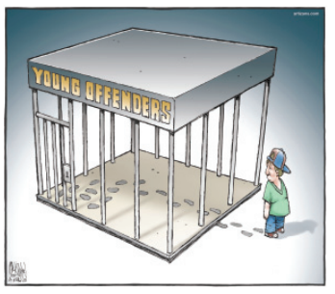

Paragraph 2: (What symbols does the cartoon use? What is being represented? What situation does the cartoon show? What does the young person’s expression communicate about his attitude? What’s the message of the cartoon?) Write your paragraph in this space provided:

Paragraph 3: Your opinion
(Compare and contrast the two sources. What are the objectives of the Youth Criminal Justice Act? Should the justice system be harder on youths who commit crimes? Support your position by referring to the sources and to your understanding of the justice system. What is the most important thing that you have learned about Canada’s justice system?) Write your final paragraph in this space provided:

