Social Studies 9: Unit 4 – Source Analysis

To what extent should Canadians support social programs and taxation?

Source 1

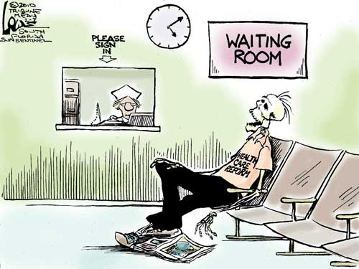

Source 2 (page 276 from textbook)

Source 3

Social Studies 9: Unit 4 – Source Analysis

To what extent should Canadians support social programs and taxation?

PART A: Planning
Source #1 | Source #2 | Source #3
What are the images/symbols? (Reference from the source) | What are the key words? (Reference from the source) | What are the key words? (Reference from the source)
What is the main idea? | What is the main idea? | What is the main idea?
How do these sources connect to social programs?
Explain how they are similar and how they differ.

Social Studies 9: Unit 4 – Source Analysis

To what extent should Canadians support social programs and taxation?

PART B: Writing
You must write a response in which you interpret each source, link it to social programs and give your opinion on the message of each source. Vocabulary that is used throughout this unit must be apparent in your writing. Follow the writing format.

Paragraph 1: Source 1 (10 marks)
- Interpret the source (analyze and describe the cartoon, what is the message?)
- Link the cartoon to a topic discussed in class
- Use an example to further explain your analysis

Paragraph 2: Source 2 (10 marks)
- Interpret the source (paraphrase the written source, what is the perspective?)
- Link the source to a topic discussed in class
- Use an example to further explain your analysis

Paragraph 3: Source 3 (10 marks)
- Interpret the source (paraphrase the written source, what is the perspective?)
- Link the source to a topic discussed in class
- Use an example to further explain your analysis

Paragraph 4: Common theme (15 marks)
- You MUST find a common theme/relationship among all 3 sources and explain for each source. (Immigration is too broad!)
- Compare and contrast the sources (1 and 3 may be similar and contrast 2 OR 1 and 2 may be similar and contrast with 3)

Communication: (5 marks)
vocabulary, sentence structure, mechanics, grammar, and organization

NOTE:

When Interpreting a Political Cartoon:
- Read any writing and interpret it
- Look at the body language of the characters – who do they represent?
- Look for the irony and satire – what is being criticized?

